SOCIETY OF THERMAL ENGINEERS OF SERBIA
11001 Belgrade, P. O. Box 522, Serbia
President of Society, phone: (011) 3370 299, e-mail: dstojiljkovic@mas.bg.ac.rs
Thermal Science – National Editorial Board
Phone: +381 11 24 55 663 fax: +381 11 245 36 70, e-mail: drustvo.termicara@gmail.com

INVOICE

No. xx/13 Date: dd.mm. 2013.
 | Full address of the Corresponding author:
Item |  |  | Total
Participation fee for the paper  Paper reference number:  Corresponding author: |  |  | 150 EUR

GRAND TOTAL xxx EUR

Important note: Taxes for transfer of money for Participation fee, have to be paid by the Corresponding author
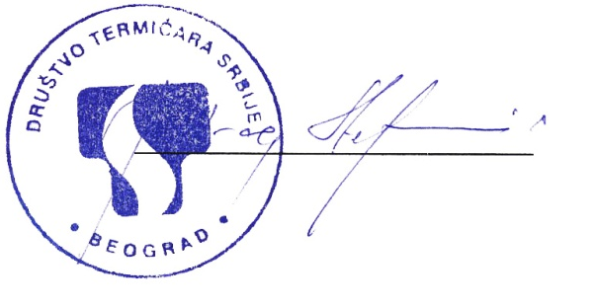

Bank account of the Society of Thermal Engineers of Serbia
(Account No. 00-708-0002751721 Commercial bank, Belgrade).

Intermediary Bank / Correspondent Bank
 |  | In EUR: | In USD:
SWIFT - BIC: |  | DEUTDEFF | SCBLUS33  Fed Wire ABA: 026002561
Name: |  | DEUTSCHE BANK AG | STANDARD CHARTERED BANK
City, Country: |  | FRANKFURT AM MAIN, GERMANY | NEW YORK,NY, UNITED STATES
Account with institution / Beneficiary's Bank
SWIFT - BIC: | KOBBRSBG |  |  | KOBBCSBG
Name: | KOMERCIJALNA BANKA A.D. BEOGRAD |  |  | KOMERCIJALNA BANKA A.D. BEOGRAD
Street: | SVETOG SAVE 14 |  |  | SVETOG SAVE 14
City, Country: | 11000 Belgrade, Republic of Serbia |  |  | 11000 Belgrade, Republic of Serbia
Beneficiary
IBAN/ Account Number: | RS35205007080002751721 |  |  | RS35205007080002751721
Company name: | DRUSTVO TERMICARA SRBIJE |  |  | DRUSTVO TERMICARA SRBIJE
Street: | MIKE PETROVICA ALASA 12-14 |  |  | MIKE PETROVICA ALASA 12-14
City, Country: | 11351 VINCA, Republic of Serbia |  |  | 11351 VINCA, Republic of Serbia

Society of Thermal Engineers of Serbia is TAX free organization.

For domestic authors the Participation fee is also 150 € , but in domestic currency, according to the Euro/Din equivalence on the day of payment, on the account 205-39132-62, Društvo termičara Srbije, Beograd, Commercial Bank, Belgrade.

Important note: Taxes for transfer of money for Participation fee, have to be paid by the Corresponding author

